Expression of Interest and
Proposal Submission Requirements for Hosting the IPOS World Congress of Psycho-Oncology

28th - 2027 nominations can be accepted up to August 1, 2024
29th - 2028 nominations can be accepted up to August 1, 2025
30th - 2029 nominations can be accepted up to August 1, 2026

Elements of the model are subject to change at the discretion of the Board, as may be necessary to support the best interests of IPOS and its National Society colleague organizations.

Table of Contents
Introduction and Congress History 3
Proposal Timeline 3
About the Congress 3
Congress Committees 4
Roles of IPOS Headquarters and Professional Conference Organizers 5
Location and Timing of the Congress 5
Theme, Logo and Objectives 5
Official Language 6
Venue 6
Exhibition 7
Continuing Education Units 7
Psychosocial Academy Pre-Congress Workshops 8
Plenary, Invited and Award Sessions 9
Concurrent Sessions and Abstract Management 9
Posters 10
Social Events 10
Business Meetings 11
Speaker Honoraria and Travel Expenses 11
Scholarships 12
Attendee Travel and Accommodations 13
Registration 13
Marketing and Publications 13
Finances and Fundraising 14
Proposal Requirements 15
Appendix A: Sample Congress Schedule 18
Appendix B: Delegation of Responsibilities 23
Appendix C: Sample Congress Budget 27

Introduction and Congress History
The International Psycho-Oncology Society (IPOS) World Congress brings together psycho-oncology practitioners and scientists to build and develop thriving scientific societies, healthcare agencies and academic institutions in all parts of the world and to integrate their knowledge toward a common language of accepted standards in comprehensive cancer care. During the World Congress, members of the international psycho-oncology community have the opportunity to share and learn about new research and best practices in the field. IPOS aims to establish culturally specific standards of psychosocial care and cancer control policy in every nation represented at the World Congress by inspiring attendees to apply their new knowledge in their respective countries.

World Congresses have been/shall be hosted in the following locations:
1992 – Beaune, France (attendance data not available)
1995 – Kobe, Japan (attendance data not available)
1996 – New York, New York, USA (attendance data not available)
1998 – Hamburg, Germany (attendance data not available)
2000 – Melbourne, Victoria, Australia (718 attendees)
2003 – Banff, Alberta, Canada (747 attendees)
2004 – Copenhagen, Denmark (507 attendees)
2006 – Venice, Italy (1,348 attendees)
2007 – London, United Kingdom (642 attendees)
2008 – Madrid, Spain (844 attendees)
2009 – Vienna, Austria (656 attendees)
2010 – Quebec City, Quebec, Canada (767 attendees)
2011 – Antalya, Turkey (499 attendees)
2012 – Brisbane, Australia (1,271 attendees – joint with COSA)
2013 – Rotterdam, Netherlands (640 attendees)
2014 – Lisbon, Portugal (603 attendees)
2015 – Washington, DC, USA (506 attendees)
2016 – Dublin, Ireland (541 attendees)
2017 – Berlin, Germany (767 attendees)
2018 – Hong Kong, HK (644 attendees)
2019 – Banff, Alberta, Canada (602 attendees)
2021 – Virtual out of Kyoto, Japan (580 participants)
2022 – Hybrid out of Toronto, Ontario, Canada (604 participants)
2023 – Milan, Italy (800 participants)
2024 – Maastricht, The Netherlands
2025 – Location confirmed and will be announced at a later date.
2026 – Location confirmed and will be announced at a later date.

The hosting organization shall benefit from global visibility and recognition as a key global player in the development of psycho-oncology.

Proposal Timeline
Proposals are requested as far in advance as possible, and a minimum of two years prior to year of proposed Congress. Submissions deadlines for each upcoming World Congress are noted on the cover page.

About the Congress
IPOS has established the World Congress as an annual event. Each World Congress shall begin with one to two full days of training workshops known as the Psychosocial Academy Pre-Congress Workshops. The Academy shall feature a faculty of world-renown psycho-oncologists and offer both half- and full-day courses to train cancer care professionals in practical psychosocial, behavioral and palliative care methods. The Congress itself shall offer three days of plenary sessions, podium lectures, symposia and posters on all aspects of psychosocial oncology, featuring both invited speakers and presenters selected from among submitted abstracts. Psychosocial Academy Pre-Congress Workshops training courses may also be integrated within the World Congress sessions. The IPOS Board of Directors requires the general Congress structure as noted above, but it also welcomes innovative approaches from the Congress organizers. It is important to remember that, as an international society, IPOS welcomes the informed contributions of psycho-oncologists representing every country and culture.

Congress Committees
The Congress shall be led by a Congress Chair (or Co-Chairs), who shall be approved by the IPOS Board. The IPOS Board shall also name a co-chair to the Congress, and that person shall report Congress developments to the Board. It is important to remember that, while the Congress shall be directed by the local Congress Chair and appointed Local Organizing Committee, it must be, first and foremost, an IPOS World Congress and, therefore, have the branding and structure expected of an IPOS World Congress.

There are two required committees for organizing the Congress: the Local Organizing Committee (LOC), which is responsible for all logistical, fundraising and publicity arrangements, and the International Scientific Committee (ISC), which is responsible for the content and structure of the Congress program (a sample program is available in Appendix A of this document). The Congress Chair should also serve as Chair both committees, or, if there are Co-Chairs, one Co-Chair may lead the LOC while the other Co-Chair leads the ISC, or both Co-Chairs may also be Co-Chairs for both committees.

In addition to the two required committees, the following subcommittee structure is recommended to ensure all Congress tasks are adequately addressed without overtaxing any one group of committee volunteers. The Congress Chair(s) may convene additional subcommittees if it is deemed necessary. Members of the subcommittees are not required to be members of the governing committees.
- Local Organizing Committee (required; oversees the planning of all local logistical elements, including but not limited to venue selection, menu selection, special event and entertainment arrangements, hotel accommodations, transportation of attendees if necessary, budgeting and finances, and fundraising); oversees the following subcommittees:
  - Logistics Subcommittee
  - Local/Regional Fundraising Subcommittee
  - Publicity Subcommittee
- International Scientific Committee (required; oversees the planning of the scientific program of the Congress, including but not limited to Academy training course selection and invitation, invited presentation selection and invitation, abstract submission process and review, placement of selected abstracts into Congress program schedule, and selection of poster award recipients); oversees the following subcommittees:
  - Psychosocial Academy Pre-Congress Workshops Subcommittee – to work in conjunction with IPOS Education Committee
  - Invited Presentation Subcommittee
  - Abstract Subcommittee
  - Poster Subcommittee

Roles of IPOS Headquarters and Professional Conference Organizers
The Congress Chair(s) may choose to hire a Professional Conference Organizer (PCO) local to the Congress location to manage the logistical elements of the Congress, or they may employ IPOS Headquarters (HQ) to assume that responsibility. A sample list of responsibilities may be found in Appendix B of this document. Other Congress administrative structures may be considered in unusual circumstances and depending upon local needs, with approval of the IPOS Board.

Location and Timing of the Congress
The location of the Congress should be a major city that is easy and convenient to get to for attendees all over the world. It should also be in a region and country that is politically and socioeconomically stable. The Congress shall be held in alternating locations around the world at the discretion of the IPOS Board.

The preferred dates of the Congress are October/November. The climate in the location should be taken into consideration when choosing a time of year so that potential weather interruptions to the schedule or flight delays for the attendees (as a result of inclement weather) are minimized. The popularity of the location as a holiday destination should also be taken into consideration when selecting dates for the Congress, as popular holiday times often result in higher prices and more limited availability for conference venues and hotel accommodations. Congress dates should also not conflict with any major religious holidays (Christian, Jewish, Muslim and Hindu holidays are of particular consideration), government holidays in the destination country, or other major scientific conferences which IPOS attendees may be planning to attend.

Theme, Logo and Objectives
The Congress Chair(s) and ISC shall determine a theme for the Congress shortly after the dates and location of the next Congress have been announced. The theme will drive the submission of abstracts, so it should be somewhat specific in order to give submitters an idea of how to present their proposed abstract, but the theme should also be general enough to allow submissions from all areas of psychosocial oncology.

The Congress logo and objectives should be developed subsequent to the theme. Ideas for the logo should be generated by the Congress Chair(s), and the actual logo may be designed by IPOS HQ or by a local graphic designer at the discretion of the Chair(s) and with the approval of the IPOS Board. The objectives of the Congress must be specific, measurable objectives for the Congress as a whole and will be submitted with the application for continuing education units. Examples of objectives from recent Congresses include:
- To promote the multi-disciplinary approach through the exchange of specialized knowledge and experience of different professionals to best meet the unique needs of cancer patients and their families
- To develop strategies to add psychosocial issues to all aspects of international cancer control
- To promote psycho-oncology best practices in the administering of palliative care

Official Language
IPOS Congresses are held in English but, on request by the LOC and Chair(s), a second language may be included in Congress presentations if it encourages the participation of local psycho-oncologists. Past Congresses have incorporated additional languages in a number of ways, including special Academy workshops and concurrent session tracks held only in the second language, consecutive translation of selected workshops or sessions, and simultaneous translation of selected workshops or sessions. Because simultaneous translation is quite expensive, it may be necessary to limit its use.

All abstracts must be written in English, even if they will be presented in another language during the Congress, in order to be included in the abstract book, which is published as a supplement to the journal Psycho-Oncology.

Venue
Venues must be reserved for the Psychosocial Academy Pre-Congress Workshops, the Congress (generally in the same facility as the Academy), the Opening Ceremony and Reception (may be in the same facility as the Academy and Congress, but not required to be), the Gala Dinner and any other special events proposed by the LOC. If a PCO is hired to manage the logistical elements of the Congress, then the PCO will negotiate the contract for all venue facilities and manage the arrangements described in this section. The proposed Congress venue should meet the following specifications:
- Congress venue facilities should be spacious enough to accommodate up to 800 participants.
- Congress venue should have capacity for plenary and general sessions of 600-800 delegates, theatre or classroom style (all in one room, or in multiple rooms with live simulcast).
- Exhibition hall must accommodate up to 75 posters per day, 15 exhibitors, breaks and lunches
- Congress venue must have at least 5 concurrent session rooms for each of 3 days (spacious enough to accommodate 150-200 people each per room, theater or classroom style) – 6 to 7 concurrent sessions are preferred (including plenary room).
- Congress venue must have a staff office for the duration of the Academy and Congress (plus at least 2 days prior to the first day of the Academy).
- Congress venue must have 5 classrooms (able to seat 30–50 people classroom style) available for each day of the Academy workshops.
- Congress venue must have accessibility for people with restricted mobility (wheelchair).
In addition, the LOC must consider the availability and cost of food and beverage, audio-visual equipment and internet access. Regarding food and beverage arrangements, a coffee and tea break must be provided mid-morning and mid-afternoon. It is recommended, if the budget will allow, that coffee and tea also be provided first thing in the morning (as well as a continental breakfast if such is not offered at the primary Congress hotels where attendees are staying) and that lunch be provided. If the budget will not allow for extra food and beverage, the venue must be situated in such a location that attendees are able to procure their own food and beverage easily and at a reasonable cost. Water should be available readily throughout all sessions and the conference venue.

Regarding audio-visual equipment, at a minimum, each Congress session room should be equipped with a computer (running a Windows operating system, version XP or more recent, with Microsoft Office installed), LCD projector and screen, and adequate microphones for the presenters. Academy workshop presenters may request additional equipment for their workshops such as flipchart writing pads with markers, DVD players and sound, etc. Internet access must be provided for the registration desk, the Congress office and Congress plenary and concurrent session rooms (to allow for a central server for presentations). Some Academy presenters may also request internet access in order to give their presentations. If possible, internet access should be available to Congress attendees. This may involve providing a small bank of computers connected to the internet that attendees may use, wireless internet (free or pay-per-use) to which attendees with laptops can connect, or a nearby café where attendees can purchase access to the internet.

In working with the Congress venue and in planning other aspects of the Congress, IPOS encourages the organizers to promote environmental responsibility as much as possible. The venue should have a commitment to recycle as many disposable materials as possible, to use repurposed or recycled products, to purchase products that are recyclable or biodegradable, etc. The Congress organizers should also attempt to promote environmental responsibility to the best of their abilities without detracting from the purpose of the Congress.

Exhibition
IPOS encourages the participation of exhibitors in the IPOS World Congress. Exhibitors are generally recruited among local organizations, so the exhibition arrangements and recruitment lie with the LOC. Past Congresses have hosted anywhere from 5 to 15 exhibitors. Non-profit organizations are allowed to exhibit for a lower fee than for-profit organizations. If a PCO is hired to manage logistical arrangements, the PCO should also manage the exhibition.

Continuing Education Units
IPOS HQ shall pursue accreditation of the Congress for the appropriate continuing education units. In most cases, this is Continuing Medical Education, or CME. CME credits are widely accepted by other professions toward an individual’s relicensure because of the strict requirements an event must meet in order to obtain CME credit. In Europe, IPOS will apply to the European Accreditation Council for CME (EACCME), which has accredited most European IPOS Congresses. Outside of Europe, the location will dictate to what accrediting body IPOS applies for CME units for the Congress.

Because physicians must remain unbiased by commercial influence during their continuing education, there are a number of standard rules and regulations for conducting a conference that has been accredited to offer CME credits. The following rules apply when being accredited by most CME accreditation bodies, and additional rules may apply depending on the specific accrediting body.
- All financial or in-kind supporters must be acknowledged and the attendees must be notified that they supported the Congress (and how).
- Financial support by commercial entities must be free of any obligation by IPOS to the supporter; for example, if a pharmaceutical company gives financial support for the Congress, IPOS cannot be obligated to give that company a free exhibit booth, Congress registration, opportunity to present to the attendees, etc. This does not apply to non-commercial entities such as charitable organizations or government agencies.
- Paid advertising cannot be placed on a page facing scientific content in a Congress publication; for example, a paid advertisement can be place inside the back cover of the Congress program book, facing an empty page intended for the attendee to take notes, but it cannot be placed in the middle of the book facing a listing of the poster titles.
- Everyone involved in organizing or presenting at the Congress must complete some sort of disclosure form where they inform IPOS if they or one of their family members receives a direct benefit from a commercial entity (such as a pharmaceutical company), including a salary, royalties, participating in a speaker’s bureau, grant support, etc. In most cases, these disclosures are collected at the time of abstract submission, but LOC and ISC (and subcommittee) members who did not submit an abstract, as well as invited presenters, may be asked to complete a form in hard copy instead. IPOS may also have to follow up with those who disclose a commercial relationship in order to clear their presentation of all potential commercial bias, and all such disclosures must be printed in the Congress program book.
- All Academy workshops and the Congress must be evaluated, including a question about the presence of commercial bias observed. IPOS HQ shall prepare the evaluations for the Chair(s) and ISC’s approval and shall tabulate the results from the returned evaluations.

Psychosocial Academy Pre-Congress Workshops
Psychosocial Academy Pre-Congress Workshops may be arranged by the ISC or may be selected by abstract submission. Please note that Academy workshops must be know before any other session has been arranged in order to open registration in a timely fashion, since the Academy workshops require separate payment from the rest of the Congress. While most Academy workshops should be offered in English, some Academy workshops may be offered exclusively in the local language to facilitate local participation.

Academy speakers are IPOS members who donate their time and expenses for the benefit of IPOS.

Plenary, Invited and Award Sessions
The ISC must plan speakers for the plenary and general sessions and for any other invited presentations to take place during the Congress. The opening and closing plenary sessions should include the opportunity for the IPOS President to speak on behalf of IPOS, and the Congress Chair(s) should also speak during these sessions. The LOC may request to invite local officials or dignitaries to speak during the Opening Ceremony and Reception or the opening plenary session. Otherwise, the plenary sessions should be organized on topics directly related to the Congress theme and should include well-known, reputable speakers from psycho-oncology and related fields. The ISC may also plan other general sessions such as controversies and concurrent invited sessions such as invited symposia. The invited symposia are frequently planned in conjunction with affiliated associations and have the benefit of offering a combined multidisciplinary perspective on the topic, as well as allowing more opportunities for publicity as the affiliated association will promote the invited symposium (and therefore the Congress) to its membership. Plenary and other invited session speakers may be offered complimentary registration fees, Gala Dinner tickets, travel and/or accommodations depending on what the budget will allow and the desires of the ISC.

In addition to the plenary sessions and invited symposia noted above, IPOS awards shall be presented during one or more plenary session of the Congress. Six awards – the Hiroomi Kawano New Investigator Award, the Noemi Fisman Award for Clinical Excellence, the Bernard Fox Memorial Award, the Arthur M. Sutherland Award, the Jimmie Holland Memorial Award and the Society Distinguished Life Fellowship Award – may be presented during each Congress. All awards shall be presented during a Congress plenary session, and the Fox and Sutherland awardees shall be allowed time (20 minutes minimum) to speak about their work during the plenary session in which they receive their awards. All award recipients, as well as all past recipients of the Society Distinguished Life Fellowship Award, shall be granted complimentary attendance at the full Congress and one complimentary Gala Dinner ticket.

Concurrent Sessions and Abstract Management
Abstracts shall be accepted for symposia, podium lectures and posters. Abstract submission should open 7 to 8 months before the Congress and should remain open for at least 2 months. The administrative end of abstract submissions shall be managed by the PCO or IPOS HQ. The questions asked during the submission process shall be determined by the ISC with input from the IPOS Board. The deadlines for submission, abstract review, abstract selection and placement in the schedule, and notifications to the authors shall be determined by the ISC with input from the IPOS Board.

After the deadline for abstract submission has passed, the abstracts should be assigned to members of the ISC for review. Abstract review is conducted as a blind review so that the reviewers do not know the names of the authors. Each abstract should be reviewed by a minimum of 2, and preferably by 3, reviewers. Abstracts submitted for poster presentations may be reviewed by only 1 person, or, at the discretion of the ISC and Congress Chair(s), not reviewed at all and automatically accepted as posters. The review criteria should be established by the ISC with input from the IPOS Board. After the review has taken place, the members of the ISC responsible for creating the program shall view the reviewer’s ratings and comments and select as many of the best-rated submissions as can fit into the Congress schedule. Attention should be paid to the topics of the presentations, attempting to fill each session with presentations on similar topics. The PCO or IPOS HQ shall notify the authors of their acceptance or decline and shall collect confirmations of participation from invited authors. Abstract authors are required to pay Congress registration fees in order to attend and give their presentations. Abstract authors who are accepted for oral or poster must register by a set date in advance in order to hold their place on the program. Abstracts for symposia or podium lectures that are declined may be invited to give poster presentations at the discretion of the ISC.

Posters
Poster presentations are generally given in three sessions, one for each day of the Congress. This allows the Congress organizers to cut expenses by requiring less room for poster boards and renting fewer poster boards per day. It also keeps the attendees interested in the poster session as new research is presented in each day’s posters. If possible, a time should be specified during each day when the posters are attended by their authors so that attendees (and poster judges) may ask questions about the information presented on the poster.

As stated above, abstracts are submitted for poster presentations, and abstracts for symposia and podium lectures that are declined may be invited to give poster presentations at the discretion of the ISC. The ISC is also responsible for judging the posters and selected poster award recipients. This has happened in numerous ways in the past Congresses. The ISC may determine the method used for selecting poster award recipients, but the function must be performed in some manner.

Social Events
Each IPOS World Congress has two primary social events: the Opening Ceremony/Reception and the Gala Dinner. The Opening Ceremony/Reception traditionally takes place on the night before the full Congress begins, after the Psychosocial Academy Pre-Congress Workshops has ended. It is open to all Congress attendees and their guests. The Congress organizers may choose to charge a small fee for tickets for those attendees who did not pay the full Congress registration fee (i.e., those attending only Academy workshops or purchasing one-day-only Congress registration) and/or for attendees’ guests. The Opening Ceremony and Reception may take place at the Congress venue or in a different venue at the discretion of the LOC. It usually features welcoming remarks from the Congress Chair(s) and possibly from local dignitaries, and it also usually includes cultural entertainment such as music or dance performances from groups who study the local traditions and culture in these art forms. There should also be free time (with background or dancing music, if preferred) for the attendees to socialize, and there should be light refreshments available.

The Gala Dinner is usually held in a special location in the city of the Congress. It may be a historic location or a museum or art gallery. It has even been held on a boat as a river cruise of the Congress city. It should either be very easy to get to using public transportation or the LOC should arrange transportation to take attendees to the site. Gala Dinner tickets are sold separately from Congress registration, or complimentary tickets may be given to Academy speakers, invited speakers, award recipients and special guests. The LOC may choose to offer additional social events at its discretion.

Business Meetings
The Congress shall include:
- A meeting room for the IPOS board for the one or two days preceding the congress. Typically this will be at the host hotel.
- Meeting room for the Journal of Psychosocial Oncology Research & Practice Editorial Board Meeting (date/time to be established during the congress)
- Access to meeting rooms during the congress for committee meetings
- IPOS Annual General Meeting
These shall be held in conjunction with the Congress and should be included as a part of the Congress budget.

Speaker Honoraria and Travel Expenses
Some guidelines on speaker benefits have been described above, but this section summarizes those benefits for inclusion in the conference budget:

The hosting partner is required to include the following in the conference budgets:

- Complimentary attendance (to the full conference, including special receptions and galas) for the IPOS President
- Complimentary attendance (to the full conference, including special receptions and galas) for the Executive Director
- Complimentary attendance (to the full conference, including special receptions and galas) for the Congress Chair (Co-Chairs)
- Travel and accommodation for the IPOS President
- Complimentary attendance (to the full conference, including special receptions and galas), travel and accommodation for a designated WHO representative.
- Travel and accommodation for the IPOS Executive Director (Toronto, Canada)
- Complimentary attendance & gala for the Congress Chair (co-chairs)

Joint Symposiums/Special Session:

- The congress schedule allows for up to 2 joint symposiums. For each special symposium, for all four sessions, all for speakers for each symposium receive complimentary attendance to the full conference.

Award Recipients

- Arthur M. Sutherland Award receives complimentary registration.
- Bernard Fox Memorial Award receives complimentary registration.
- Noemi Fisman Award for Lifetime Clinical Excellence receives complimentary registration.
- Hiroomi Kawano New Investigator Award receives complimentary registration.
- Jimmie Holland Award receives complimentary registration.

Invited Plenary Speakers:

- All registration fees for the World Congress conference will be waived for invited speakers up to a maximum of 3 invited speakers.
- Plenary speakers are invited as guests to the Gala dinner (when held.)
- For plenary speakers delivering a full standalone plenary session, a travel budget will be available (this will be established based on location. The budget will be set to cover economy class travel and two nights accommodation at the host location or designated hotel). Speakers will be responsible for coordinating and paying for their own travel and accommodation unless otherwise noted.

- For plenary speakers delivering a joint plenary session (less than 30 minutes per presenter) a travel budget will be provided (sufficient to cover 2 nights hotel accommodation at the host location or designated hotel & potentially travel if budget allows for). Speakers will be responsible for coordinating and paying for their own travel and accommodation unless otherwise noted.

- IPOS is a charity. The co-host of the Congress will also be a charity or not-for-profit organization. As such, speaker honorariums are only extended if within the approved Congress budget. This is at the discretion of the organizing committee.

Invited Workshop Speakers:

- All workshop presenters who plan on attending the full conference, they must register to attend.
- Workshop presenters are responsible for all aspects of their travel.

Scholarships
In the past, IPOS has facilitated Congress participation by scholars from low- and middle-income countries and plans to continue this effort by working with Congress organizers to seek funding for scholarships to future World Congresses. In this way, IPOS aspires to improve cancer care in low- and middle-income nations. The LOC should assist IPOS in raising funds to support scholarships for individuals from low- and middle-income countries. IPOS shall collect applications from potential scholarship recipients, and the LOC shall determine which applicants are offered scholarships and how much funding they are permitted to have. Scholarship recipients are expected to have their Congress registration fees, and potentially their Academy workshop fees, waived.

Attendee Travel and Accommodations
The LOC should compile information to put on the travel webpage of the Congress website with useful information for travelers attending the Congress. This may include entry visa requirements and fees, taxes upon arriving in or leaving the country, sight-seeing information for attendees and their guests, information on local airports and their distance/cost of a taxi ride to hotels and the Congress venue from the airport, information on subway systems and other public transportation, and other relevant travel information as identified by the LOC.

The LOC shall be responsible for identifying hotels near the Congress venue in which attendees can stay. If a PCO is hired to assist with the logistical arrangements of the Congress, it may identify and contract with hotels. If a PCO is not hired, IPOS HQ will assist the LOC with this task and will, if possible, negotiate contracts with hotels that will pay IPOS a commission on the hotel rooms sold. The accommodations should be acceptable for a wide variety of financial needs, including the identification of hostels or other low-cost accommodations for students and those with few financial resources. All accommodations should either be within walking distance of the Congress venue or should be by short ride on public transportation or taxi.

Registration
If a PCO is employed, the PCO shall handle all aspects of registration. Registration shall open no less than 4 months prior to the Congress, with an early registration deadline approximately 1.5 months prior to the Congress. Those completing their registration prior to the early registration deadline shall enjoy a substantial discount on registration fees. Registration fees may be collected in US Dollars and/or in the local currency. There shall be several registration categories (e.g., IPOS and host organization members, Federation Society members, students or low/middle-income country residents, and non-members). Students and low/middle-income country resident shall pay the lowest rates while non-members pay the highest rates. Early and regular registration fees shall be set for each registrant class in each of the following categories: two-day Academy workshop (if necessary), one-day Academy workshop, half-day Academy workshop, full 3-day Congress, and one-day-only of the Congress. Social event tickets shall cost a single price, regardless of the registrant class or timing of the registration. The pricing of all registration categories shall be set by the LOC based on the budget, with input from the IPOS Board.

Marketing and Publications
Either the PCO or IPOS HQ, with the input of the Congress Chair(s), shall develop and maintain a Congress website. This website shall be the central location for information about the Congress, including registration information (and links to online registration), grant supporters, exhibitors, abstract submission, Academy and Congress schedules, travel and accommodation information, venue, CME credits, social events, etc. If the LOC believes that portions of the website should be in the local language to encourage more local participation, they may translate the most relevant web pages into a second language and provide the translations to IPOS HQ to post to the website.

The PCO or IPOS HQ shall promote the Congress via e-mail messages to the IPOS e-mail distribution list, the IPOS Facebook page, and by seeking out relationships with affiliated organizations who will promote the Congress to their e-mail distribution lists. The Congress shall also be promoted by printing postcards or flyers for IPOS Board members to distribute during any conferences they attend in the year leading up to the Congress, and IPOS Board members will include a PowerPoint slide about the Congress at the end of any presentations they give at other conferences in the year leading up to the Congress. The LOC should also seek opportunities to advertise the Congress to psycho-oncology practitioners in the country where the Congress is being held. They may take the text of the IPOS e-mail messages and translate it into the local language if this is deemed a more effective method of marketing than transmitting the message in English. The host organization should send the same e-mail messages to its e-mail distribution list that IPOS HQ sends, either in English or in the national language, whichever is deemed most effective. The LOC should also attempt to get other related organizations to send the messages to their e-mail distribution lists.

The PCO or IPOS HQ shall be responsible designing the appearance and content of all major publications relating to the Congress with the input of the Chair(s). This includes the website, e-mail communications, postcards/flyers, advertising in journals or other publications, an exhibitor and supporter prospectus, the Congress abstract book, the Congress program book, the Congress final report, and any other publications or promotions connected with the Congress.

Finances and Fundraising
It is important to note that the World Congress is considered a business arrangement, designed to provide working capital to IPOS in support of future Congresses and in support of all other IPOS programs and services, including the IPOS Federation, IPOS membership services, IPOS Press and Core Curriculum. The income generated by each World Congress provides critical financial subsidy for member services and outreach to provide psychosocial services to every nation and culture of the world. Meetings and discussions shall take place between IPOS, local cancer organizations, local authorities and convention bureaus regarding benefits offered to IPOS.

To this end, the host organization must work with IPOS HQ and the IPOS Board to develop a satisfactory budget that includes all projected income and expenses associated with the Congress. IPOS advises that the organizers slightly underestimate income and slightly overestimate expenses in order to provide a financial cushion for the Congress. A preliminary budget should be included in any proposal to host a Congress. A sample of the necessary budget categories is available in Appendix C.

Financial support/net income from the Congress must be at a level guaranteed to pay any Headquarters fees involved in service to the Congress and return an additional financial profit to IPOS, as this is a primary source of income to IPOS. Net income to the Society is negotiable, but it generally must be at least $35,000 USD. Net profits above this amount may be shared with the host organization. A profit-sharing model that is mutually agreeable to both the host organization and the IPOS Board should be presented in any proposal to host a Congress.

In order to raise enough funds to provide IPOS with a minimum profit and allow remaining profits to benefit both the host organization and IPOS, it is likely that support will need to be generated outside of registration fees. The LOC is recommended to appoint a Fundraising Subcommittee that shall focus exclusively on requesting financial support from local companies, government entities and other organizations. IPOS HQ may be employed to assist with this fundraising effort by preparing a grant proposal document that can be modified by the LOC to apply for funding with various organizations. IPOS HQ may also be employed to apply for funding to organizations with which IPOS has had a successful grantor-grantee relationship in past years, but the majority of grant funding is likely to come from local sources, so the LOC must be prepared to engage in significant fundraising efforts. It should remember that funds must be raised for both the Congress in general and for scholarships for attendees from low- and middle-income countries.

Proposal Requirements

Participation in the Congress must be entirely free from restrictions of gender, race, nationality, social class, religion, ethnicity or any other demographic categories. Therefore, sites that do not allow individuals from one or more demographic categories to participate must automatically be excluded from consideration.

Ideal prospective host organizations shall be members of the IPOS Federation and meet all of the following criteria (other organizations may also be considered):
- Be a non-profit, non-governmental organization recognized by the establishing authority⁺ of the respective country or region, if such authority exists; if such authority does not exist, application may be made to the IPOS Board of Directors for special consideration;
- Be multidisciplinary in philosophy and governance;
- Have individual professional members who practice psycho-oncology;
- Actively promote psycho-oncology in its country or region;
- Sponsor education and networking opportunities with specific psycho-oncology emphasis;
- Perform constructive activities in psycho-oncology; and
- Support IPOS activities such as the Federation of National Psycho-Oncology Societies, the Multilingual Core Curriculum of Psycho-Oncology, the World Congress of Psycho-Oncology, IPOS Press, etc.
⁺for example, establishing authority in the US is the State Corporation Commission where the organization was incorporated and the Internal Revenue Service, which confers not-for-profit status.

The written proposal should include the following:
- Proposed dates, locations and venues (with supporting rationale for why these have been selected)
- Proposed theme and objectives
- Proposed Congress Chair(s) (with information about his/her qualifications for filling this important role)
- Proposed program schedule (an outline of the suggested schedule for the Academy and Congress and all activities)
- Proposed budget (including all proposed income and expenses; details should include plans for grant support, registration fees and scholarship plans)
- Proposed accommodations for attendees (including distance from proposed venues and how attendees will get to venues, as well as the range of per-night costs for accommodations)
- Travel arrangements that will be necessary for attendees to get to Congress (include estimated travel costs and methods from major world cities such as New York City, Buenos Aires, London, Paris, Tokyo, Beijing, etc.)
- Marketing plan
- Letters of support from other oncology and psycho-oncology organizations in the country/region
- Letters from relevant authorities ensuring top-level support of government and health authorities
- Benefits of the proposal (describe why IPOS should select your proposal over other proposals)

The IPOS Board of Directors shall evaluate invited presentations and accompanying proposals against criteria that include, but are not limited to, the following:
- If the proposal addresses all points that have been requested
- The soundness of the proposed budget and the fundraising plan
- The suitability of the proposed Congress venue facilities for a typical Congress schedule
- The convenience of the proposed venue to hotel rooms, airports and local transportation
- Accessibility for people with restricted mobility (wheelchair) at the Congress venue and hotels and on public transportation
- The proposed country’s visitor visa requirements, including the cost of a visa and any restrictions that might limit Congress attendance by individuals of other nationalities
- The political and social stability of the proposed host country
- The ability of the proposed host organization to support and assist in the organization of a successful Congress, including the experience of the proposed Chair(s) in leading a successful conference previous to this
- The tourism and convention appeal of the proposed destination
- Locations of previous Congresses (i.e., if the proposed Congress site is too close to other sites where the Congress is to be held in the immediately preceding year)

The decision on the location of the Congress shall be made by the IPOS Board of Directors. If the Board feels that multiple proposals are favorable, it reserves the right to propose that some of the bidders be considered for a future Congress. The proposed venues shall be requested to submit bids and the best offers shall be considered. As part of the Congress budget, the host organization shall include site visits to be made by up to three (3) IPOS representatives to meet the host society representatives, local and government authorities, cancer/health authorities and venue and destination bureaus. IPOS Headquarters shall make every effort to arrange such site visits at a reduced cost to IPOS through the city’s convention and visitor’s bureau. The host country for each Congress shall be announced by the IPOS Board of Directors when selection is made.

Elements of the model are subject to change at the discretion of the Board, as may be necessary to support the best interests of IPOS and its National Society colleague organizations.

Appendix A:
Sample Congress Schedule

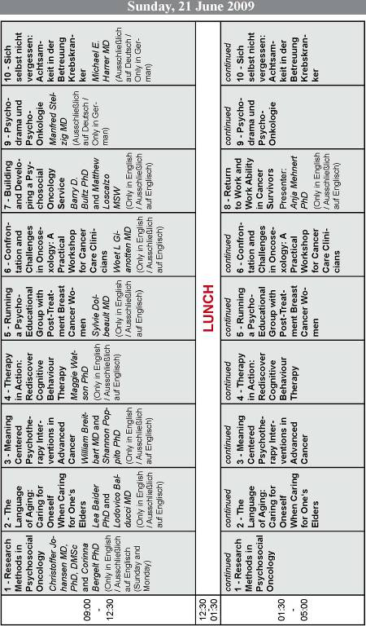

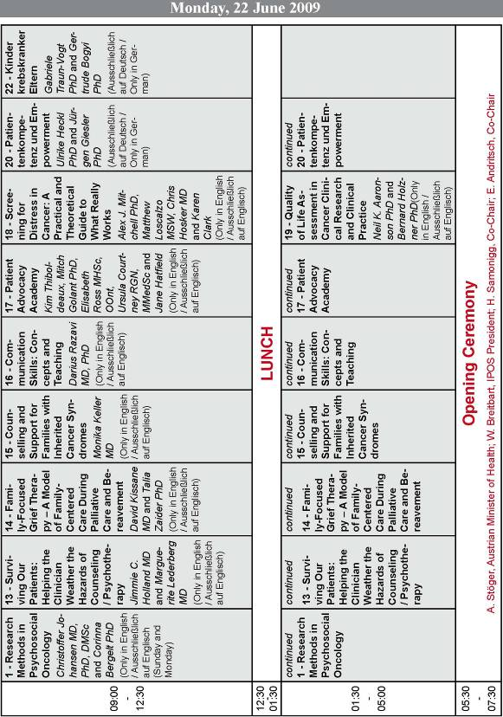

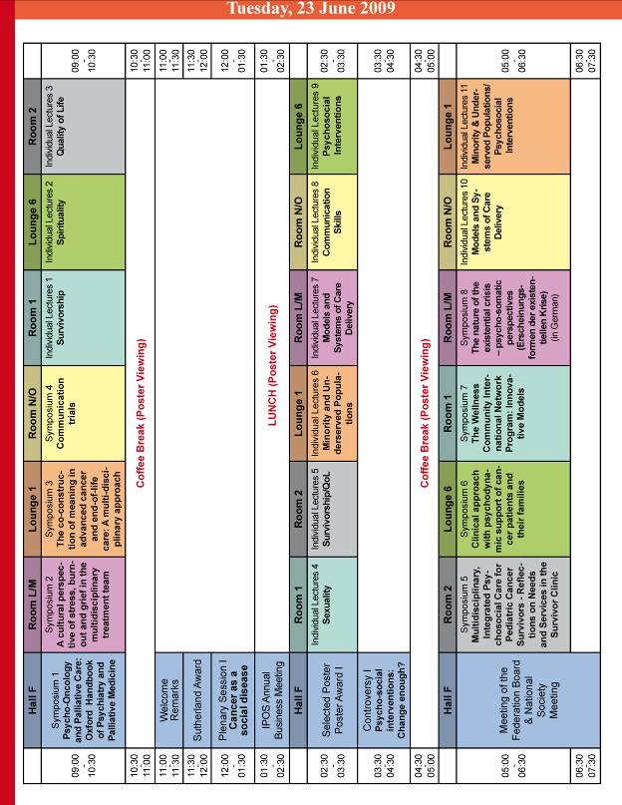

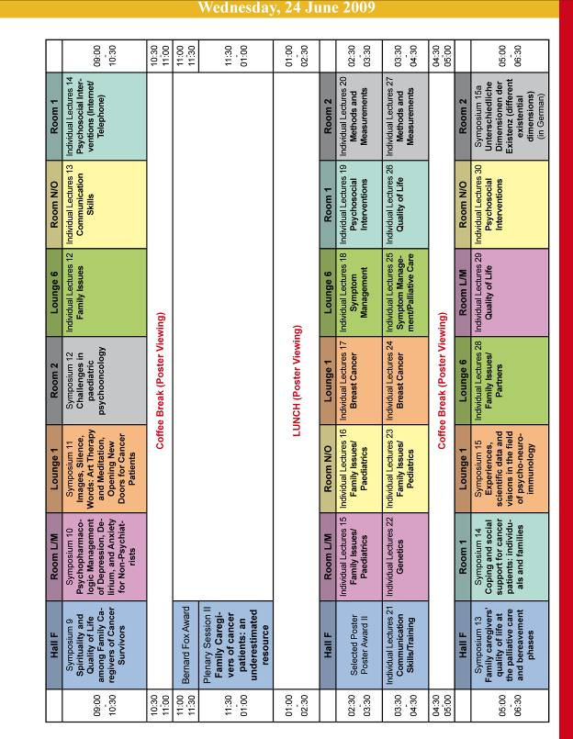

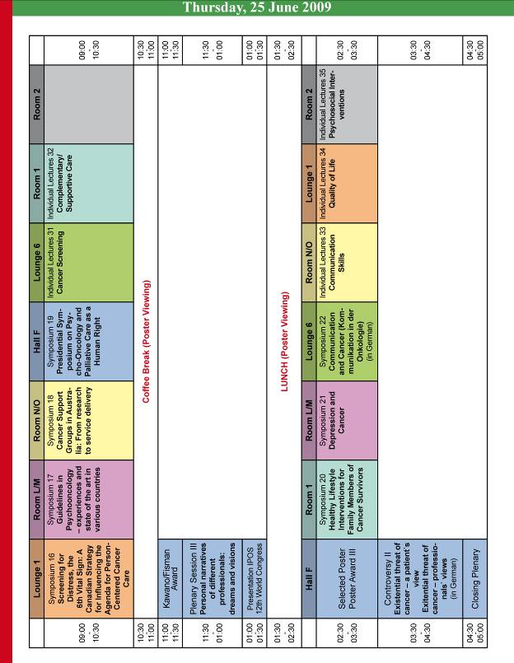

Appendix B:
Delegation of Responsibilities
The table below includes the tasks required to plan a World Congress – the X/x indications are examples only – the submitting organization is expected to indicate specifically how it plans to execute each task.

- BoD includes IPOS Board of Directors.
- HQ includes IPOS Headquarters staff.
- Chair includes the Congress Chair or Co-Chairs.
- LOC is the Local Organizing Committee and should include the Congress Chair(s) and designated colleagues who are greatly involved in assisting the Chair(s) with the logistical and financial planning of the Congress.
- ISC is the International Scientific Committee and should include the Congress Chair(s) and designated internationally-recognized psycho-oncology professionals who are greatly involved in assisting the Chair(s) with planning the Congress scientific program.
- PCO is a company of local professional conference organizers, designated by the LOC and hired to assist LOC. If a PCO is not hired, IPOS HQ may be hired to complete these tasks.
- The designation “X” indicates ultimate responsibility; the designation “x” indicates an actively supporting role.
 | TASK | BoD | HQ | Chair | LOC | ISC | PCO
Programming
 | Set deadlines/benchmark dates for abstract submission, review, and placement and registration policies |  | X | x | x
 | Recruit and select members of the LOC and ISC | x |  | X
 | Develop theme, logo and objectives for the Congress | x | x | X | X | X
 | Develop the format for the scientific program and Academy | x |  | X |  | X
 | Develop training topics for the Academy | x |  | X |  | X
 | Identify and recruit speakers for the Academy | x |  | X |  | X
 | Identify and recruit keynote and invited speakers for the Congress | x |  | X |  | X
 | Negotiate and execute contract for online abstract submission site |  |  |  |  |  | X
 | Manage technical aspects of abstract submission |  | x | x |  |  | X
 | Identify abstract reviewers | x |  | X |  | X
 | Review abstracts |  | x | X |  | X
 | Place abstracts in program schedule/grid | x | x | X |  | X
 | TASK | BoD | HQ | Chair | LOC | ISC | PCO
 | Notify abstract authors of the approval or decline of their abstracts |  |  | x |  | x | X
 | Track speaker acceptances (after author notifications have been sent) |  | x | x |  | x | X
 | Collect faculty release and disclosure forms to meet continuing education requirements |  | x | x |  | x | X
 | Produce abstract book |  | x | x |  | x | X
 | Design and produce registration brochure and program book |  | x | x | x |  | X
 | Contact local/national officials for patronage, in-person welcome |  | x | X | X |  | X
 | Recruit session coordinators/moderators for the Congress | x | x | X |  | X
 | Evaluation preparation |  | x | x |  | x | X
 | Application for and management of CMEs |  | X | x | x | x
 | Collect speaker presentations and permissions to post on website |  | x | x | x | x | X
 | Speaker/presentation/session management onsite |  | x | x |  | x | X
 | Tabulate and report results from Academy and Congress evaluations | x | x | x |  | x | X
Financial
 | Develop relationships with potential grantors to obtain Congress funding | x | X | X | X
 | Develop budget and submit to IPOS BoD for approval | x | X | X | X |  | x
 | Submit grant applications/grantor requests | x | X | X | X
 | Follow-up with potential grantors | x | X | X | X
 | Recruit exhibitors/delegate resource sponsors | x | x | X | X |  | x
 | Propose registration fees for approval of IPOS BoD | x | X | X | X
 | Propose cancellation/refund policies for approval of IPOS BoD | x | X | X | X
 | Make banking arrangements in local currency (if necessary) | x | x | X | X |  | X
 | TASK | BoD | HQ | Chair | LOC | ISC | PCO
 | Handle financial receipts and disbursements pre- and post-conference | x | X | x | x |  | X
 | Prepare and mail final reports/packages to Congress grantors | x | X | X | X |  | X
 | Handle VAT collection and/or reimbursement (if necessary) | x | X | X | X |  | X
Logistics
 | Develop and maintain Congress website |  | x | x | x | x | X
 | Prepare exhibitor/supporter prospectus |  | x | x | x |  | X
 | Provide support for local arrangements and onsite support staff |  | x | X | X |  | X
 | Develop and produce marketing materials (including e-mails) |  | x | x | x |  | X
 | Select hotel(s) for Congress | x | x | X | X |  | X
 | Select venues for Academy, Congress, special events | x | x | X | X |  | X
 | Negotiate and execute contracts with hotel(s), with approval of IPOS BoD | x | x | X | X |  | X
 | Negotiate and execute contracts with venue(s), with approval of IPOS BoD | x | x | X | X |  | X
 | Contract convention cancellation insurance | x | x | X | X |  | X
 | Manage technical aspects of registration and data entry through iMIS |  |  | x | x |  | X
 | Execute contract and arrangements for entertainment at Opening Ceremony, Gala Dinner, etc | x | x | X | X |  | X
 | Request and obtain Academy materials and room setup/audio-visual needs |  |  | x |  | X | X
 | Negotiate and execute contract with exhibitor services provider | x | x | X | X |  | X
 | Manage arrangements for and communicate with exhibitors and grantors |  | X | X | X |  | X
 | TASK | BoD | HQ | Chair | LOC | ISC | PCO
 | Direct all onsite communication and management (food/beverage, room setup, audio-visual needs, sleeping room block, etc.) | x | x | X | X |  | X

 | Arrangements with Convention/Visitors Bureau to receive information for bags, support | x | x | X | X |  | X
 | Arrangements for additional social events (if desired) | x | x | X | X |  | X
 | Make travel or transportation arrangements for attendees to get to social events (if necessary) |  |  | X | X |  | x
 | Freight/shipping/customs management |  |  |  |  |  | X
 | Select menus |  |  | X | X |  | x
 | Arrange for production of signage and other printed materials |  |  | x | x |  | X
 | Selection of Invited Speaker gifts, Attendee bag/gifts |  |  | X | X | X | X
 | Order bags, gifts and other promotional items |  | x | x | x |  | X
 | Produce badges and certificates |  |  | x | x | x | X
 | Supply ordering for onsite office |  |  | X | X |  | X
 | Crisis management plan preparation |  | x | x | x |  | X
 | Volunteer/onsite support staff management |  | x | X | X |  | X
 | Direct registration desk and check-in onsite |  |  | x | x |  | X
 | Monitor logistical details onsite (food/beverage, room setup, audio-visual, etc.) |  | x | x | x |  | X
Miscellaneous
 | Monthly conference calls to ensure common understanding and planning (possibly weekly in month leading up to Congress) |  |  | X | X |  | X
 | Develop and implement public relations and marketing plan | x | X | X | X |  | X
 | Award management (with the IPOS Awards Committee) | x | X
 | Scholarship applications and administration | x | X | X | X

Appendix C:
Sample Congress Budget


